1. grep word doc

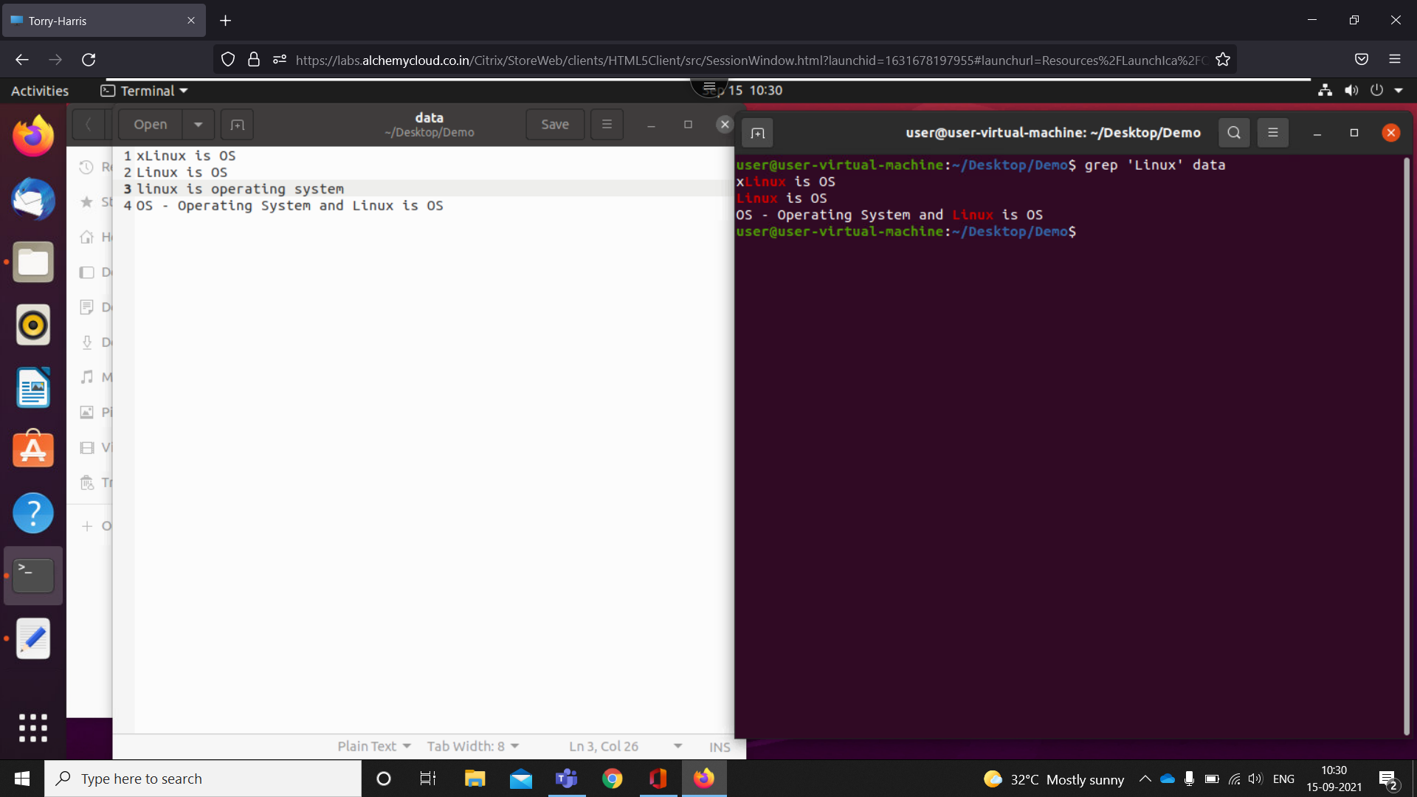

-starting with word

1. grep -c 'Linux' 'src'

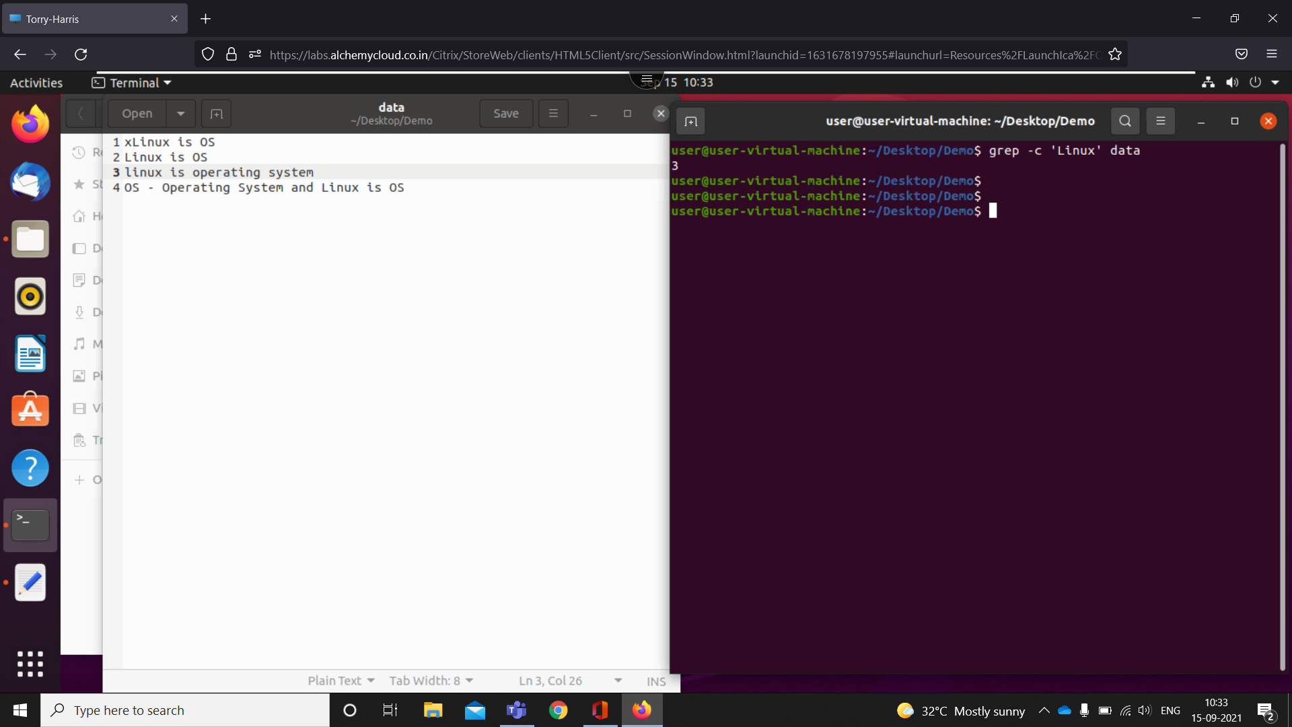

-print no of times linux in that doc

1. grep -l 'linux' doc

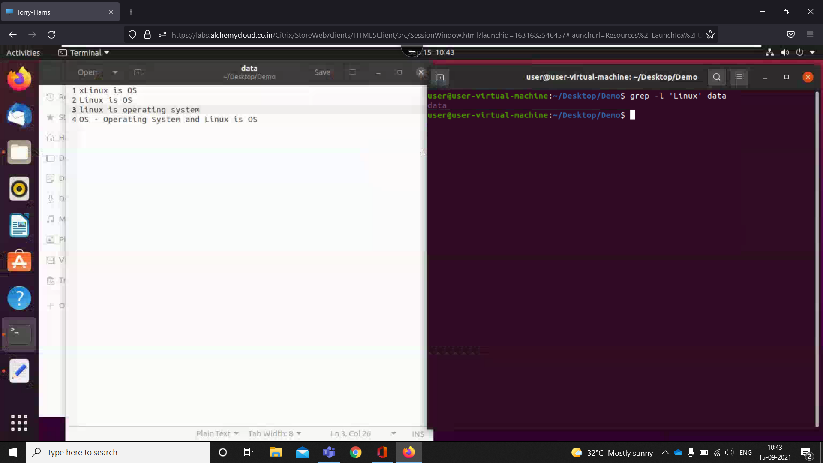

1. grep -w word doc

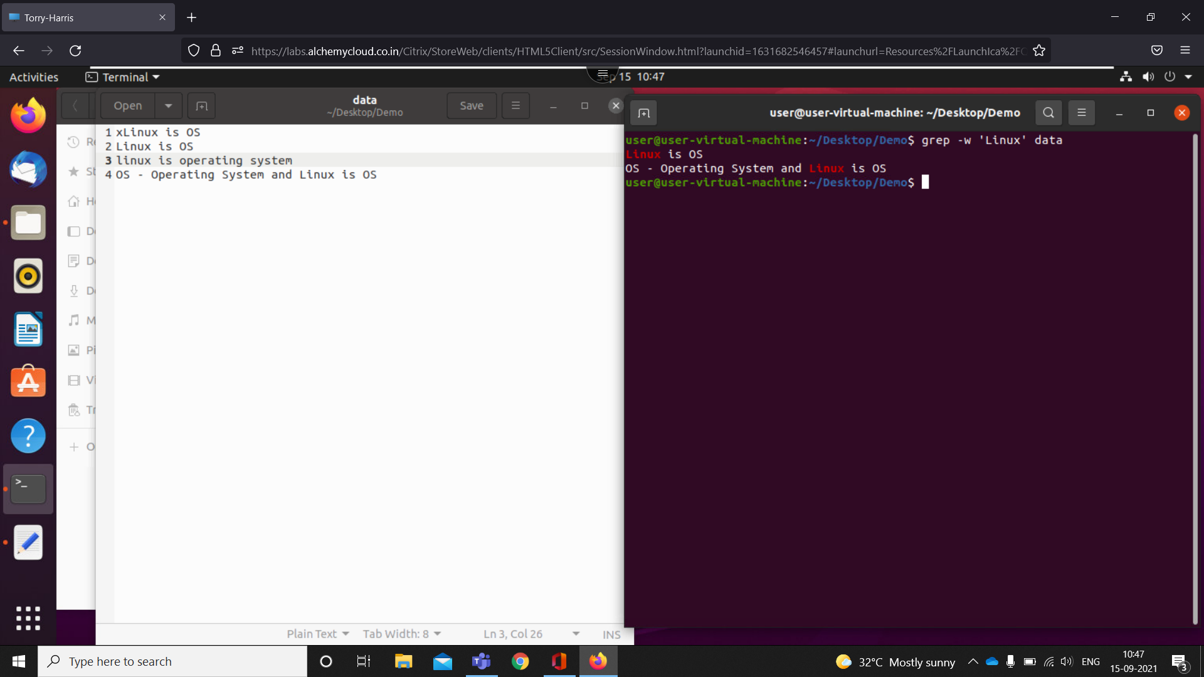

-print full fleshed word in the file

1. grep -o word doc

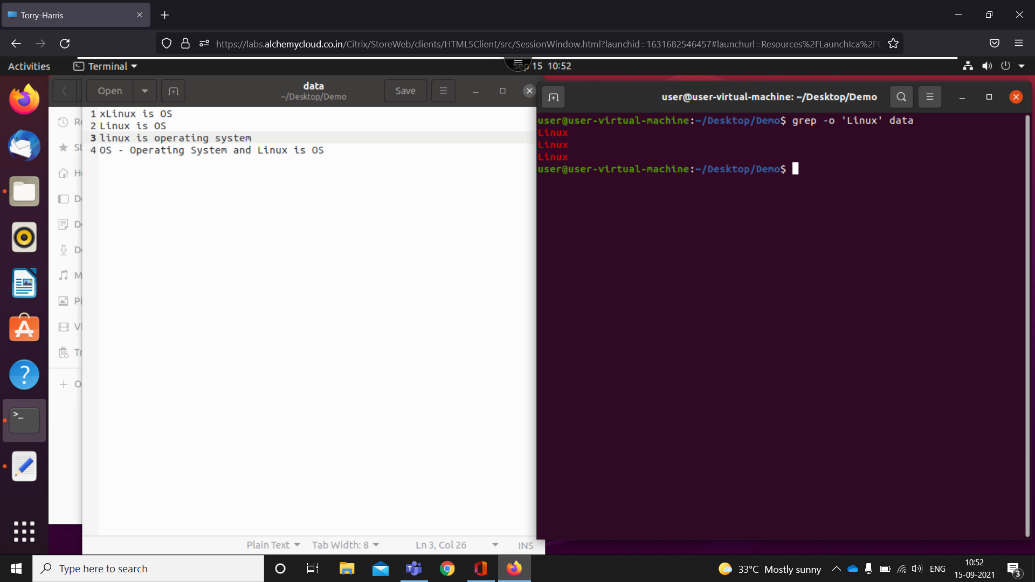

-substring

1. grep -i word doc

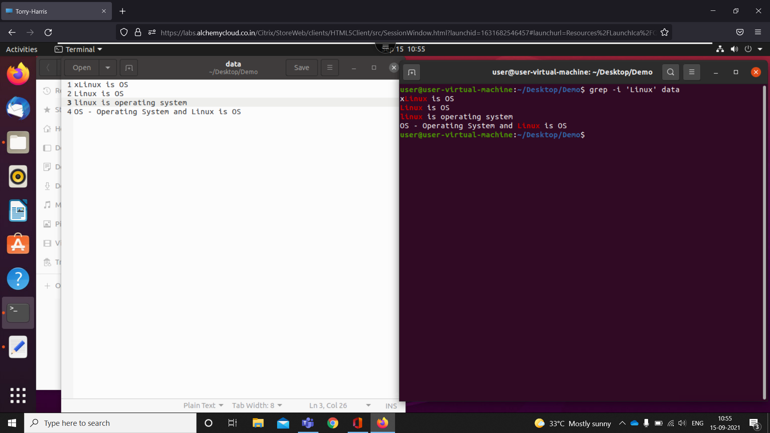

-ignoring case

1. grep -n word doc

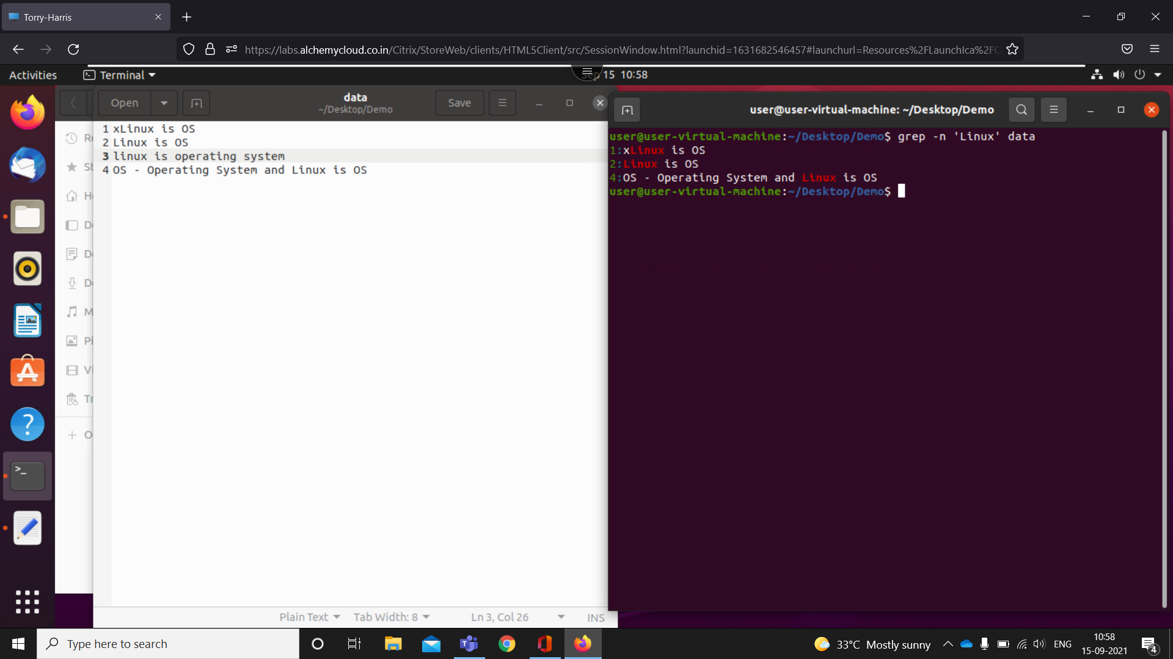

-with number line

1. grep -v word doc

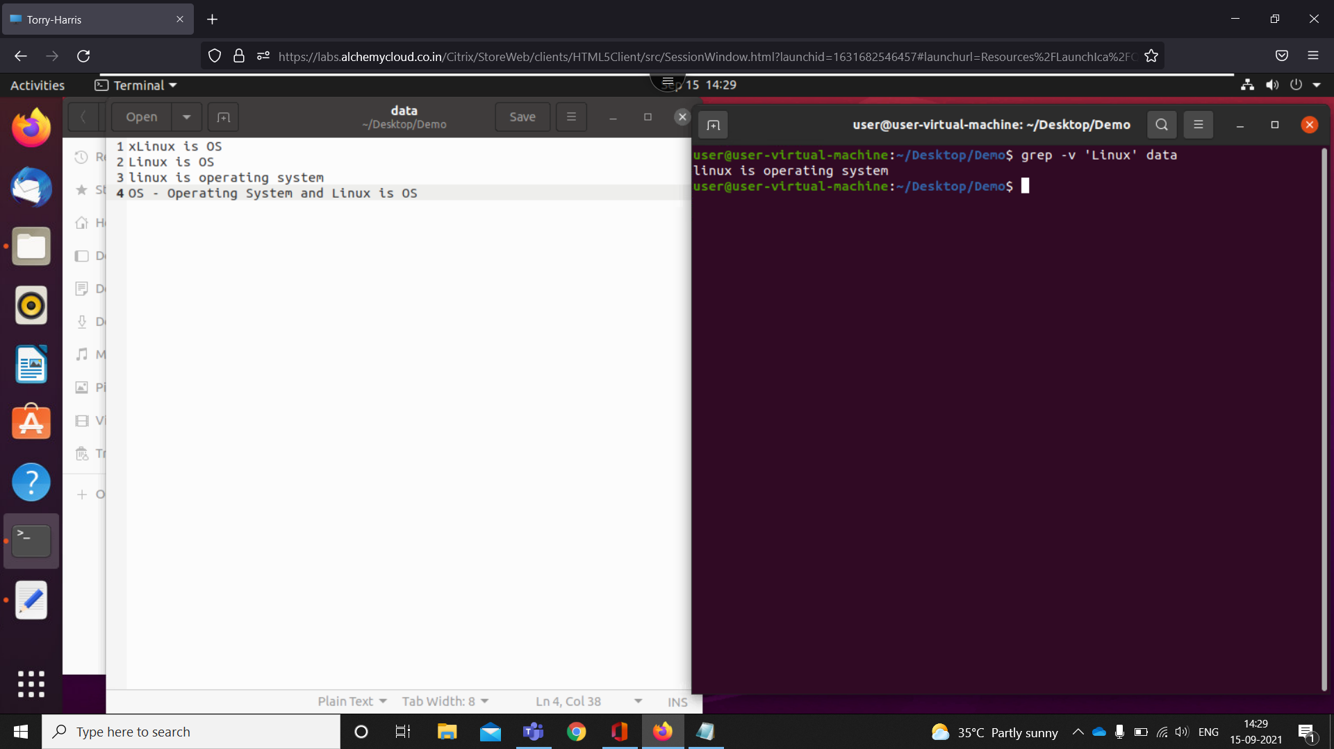

-all lines without that word

1. grep '^word' doc

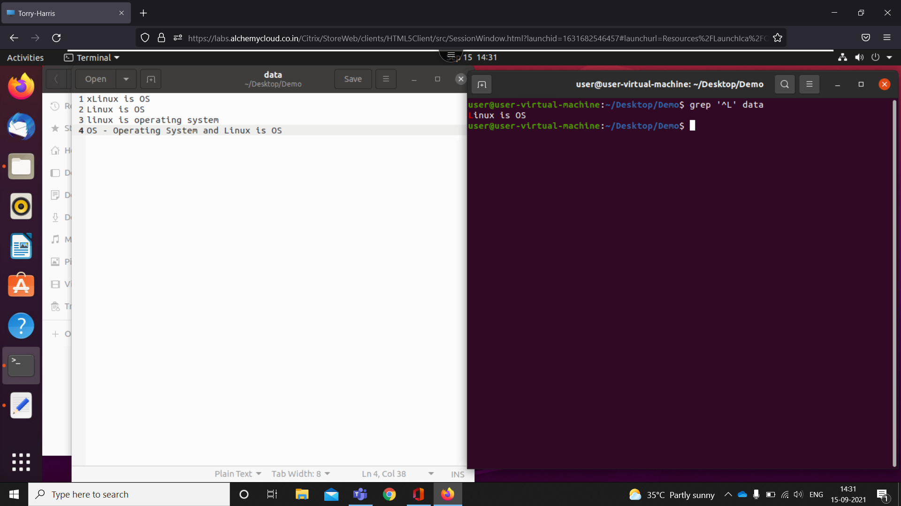

-starts with that word

1. grep 'word$' doc

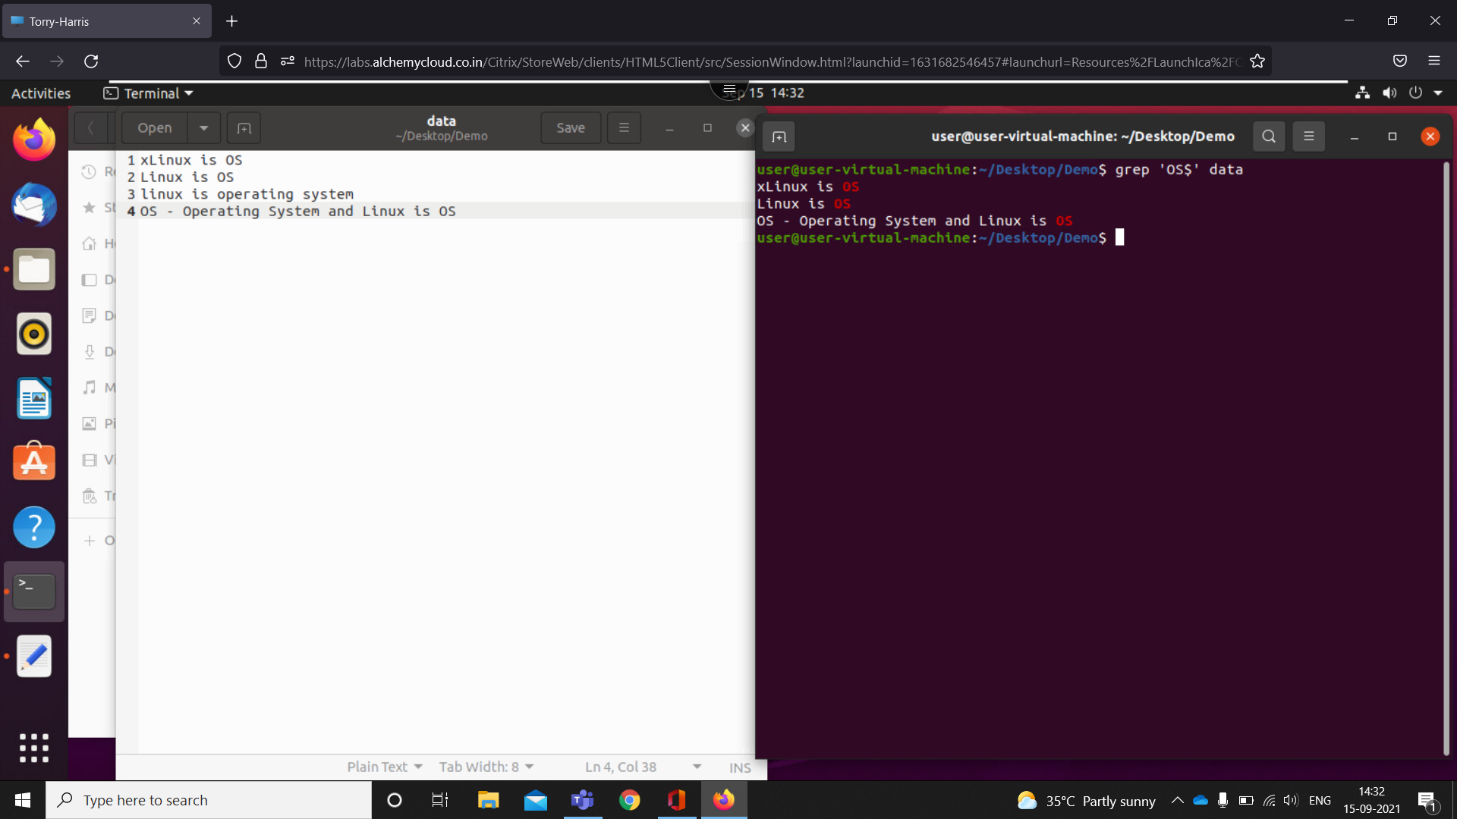

-ends with that word

1. grep -ni -E '^start .\* end$' doc

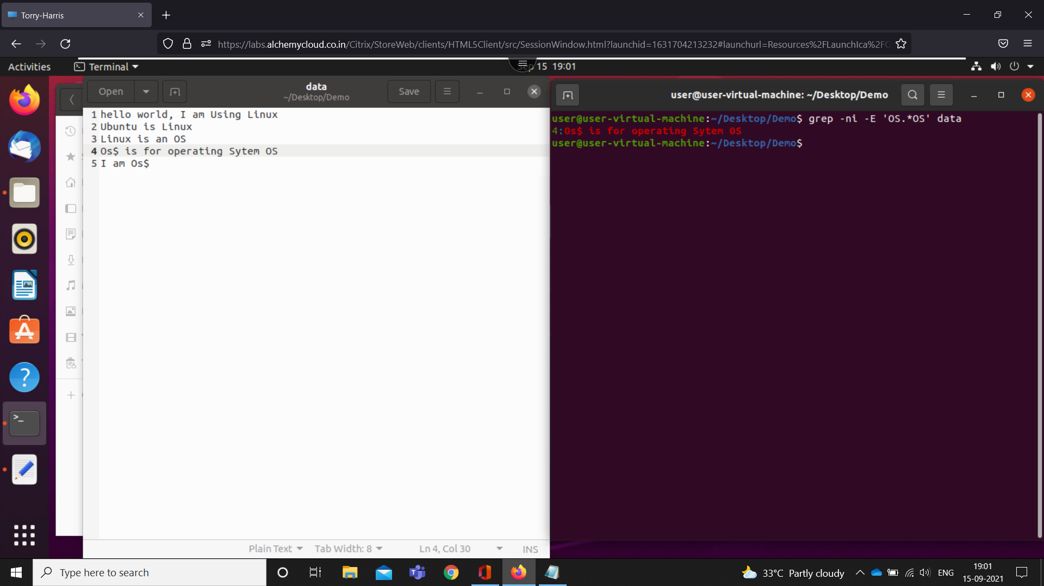

1. grep -ni -E '^start . end$' doc -fetch only words

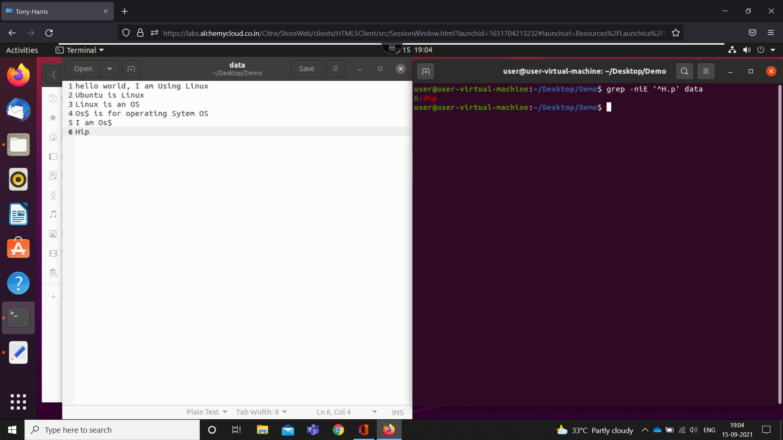

1. grep -ni -E '^start. .end$' doc

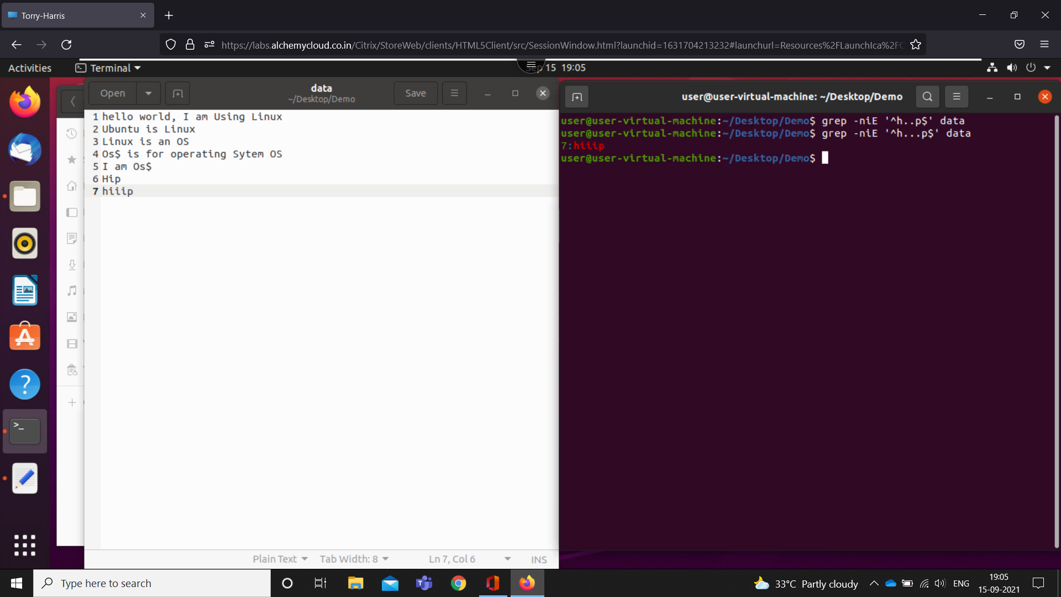

1. cut -d '$' -f 1 doc - prints character after $

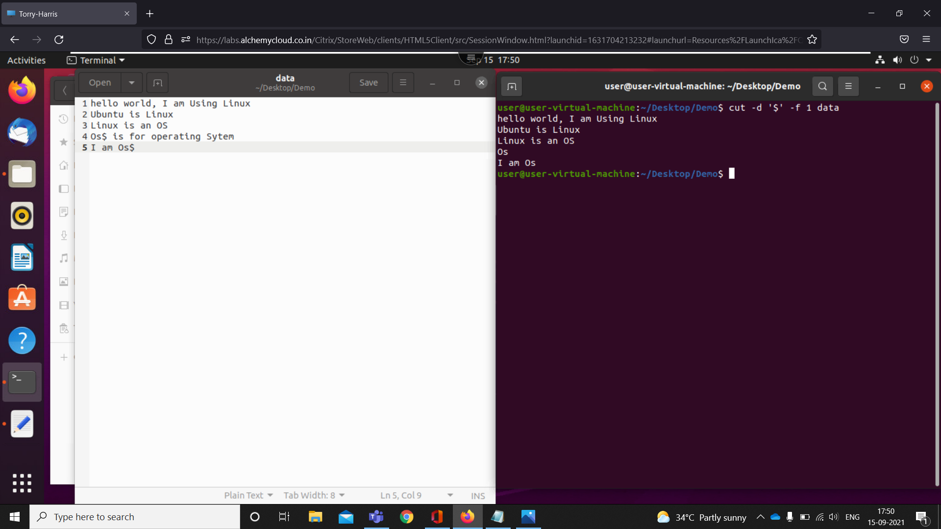

1. cut --complement -d '$' -f 1 doc - prints character before the $

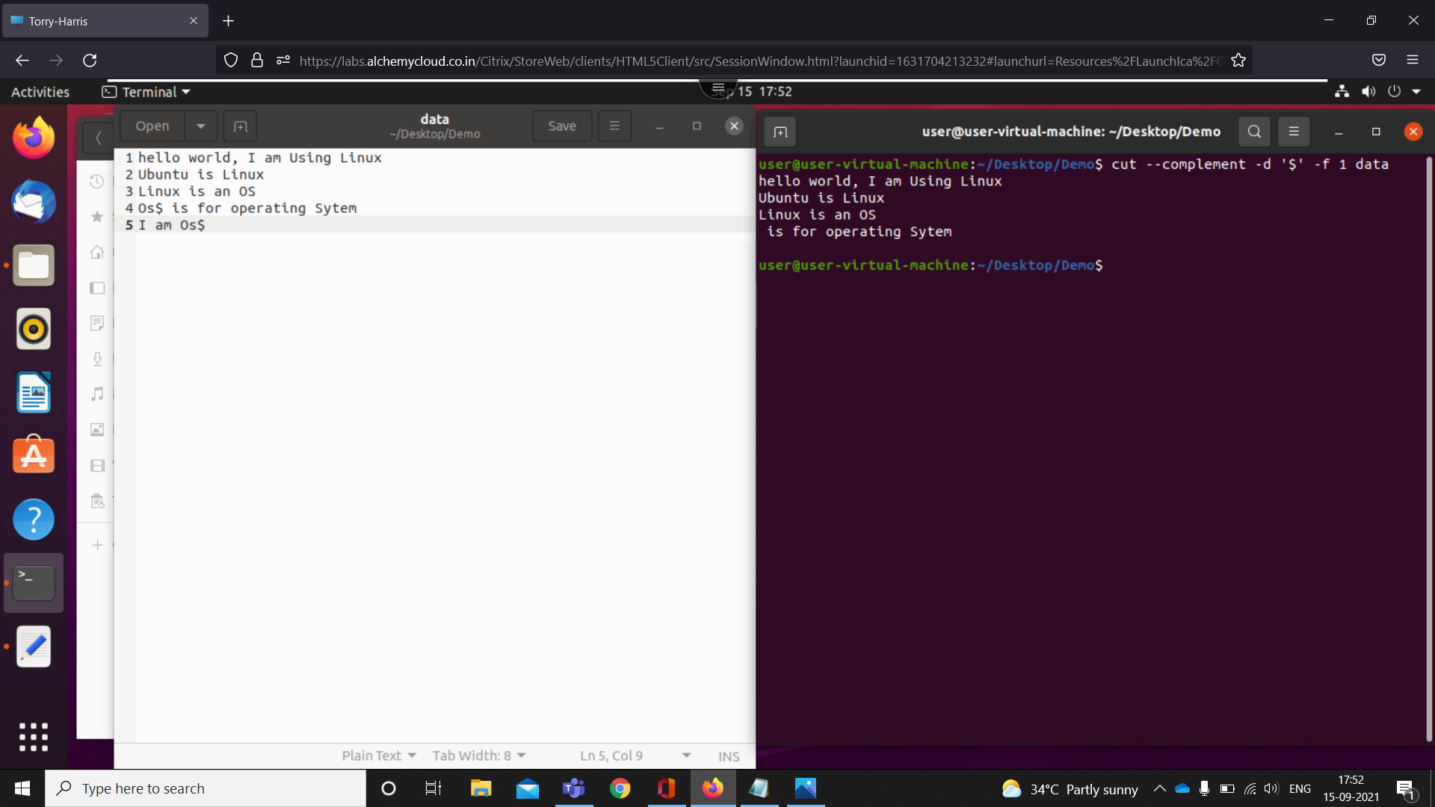

1. cut -d ' ' -f 1 doc - prints words before 1st space

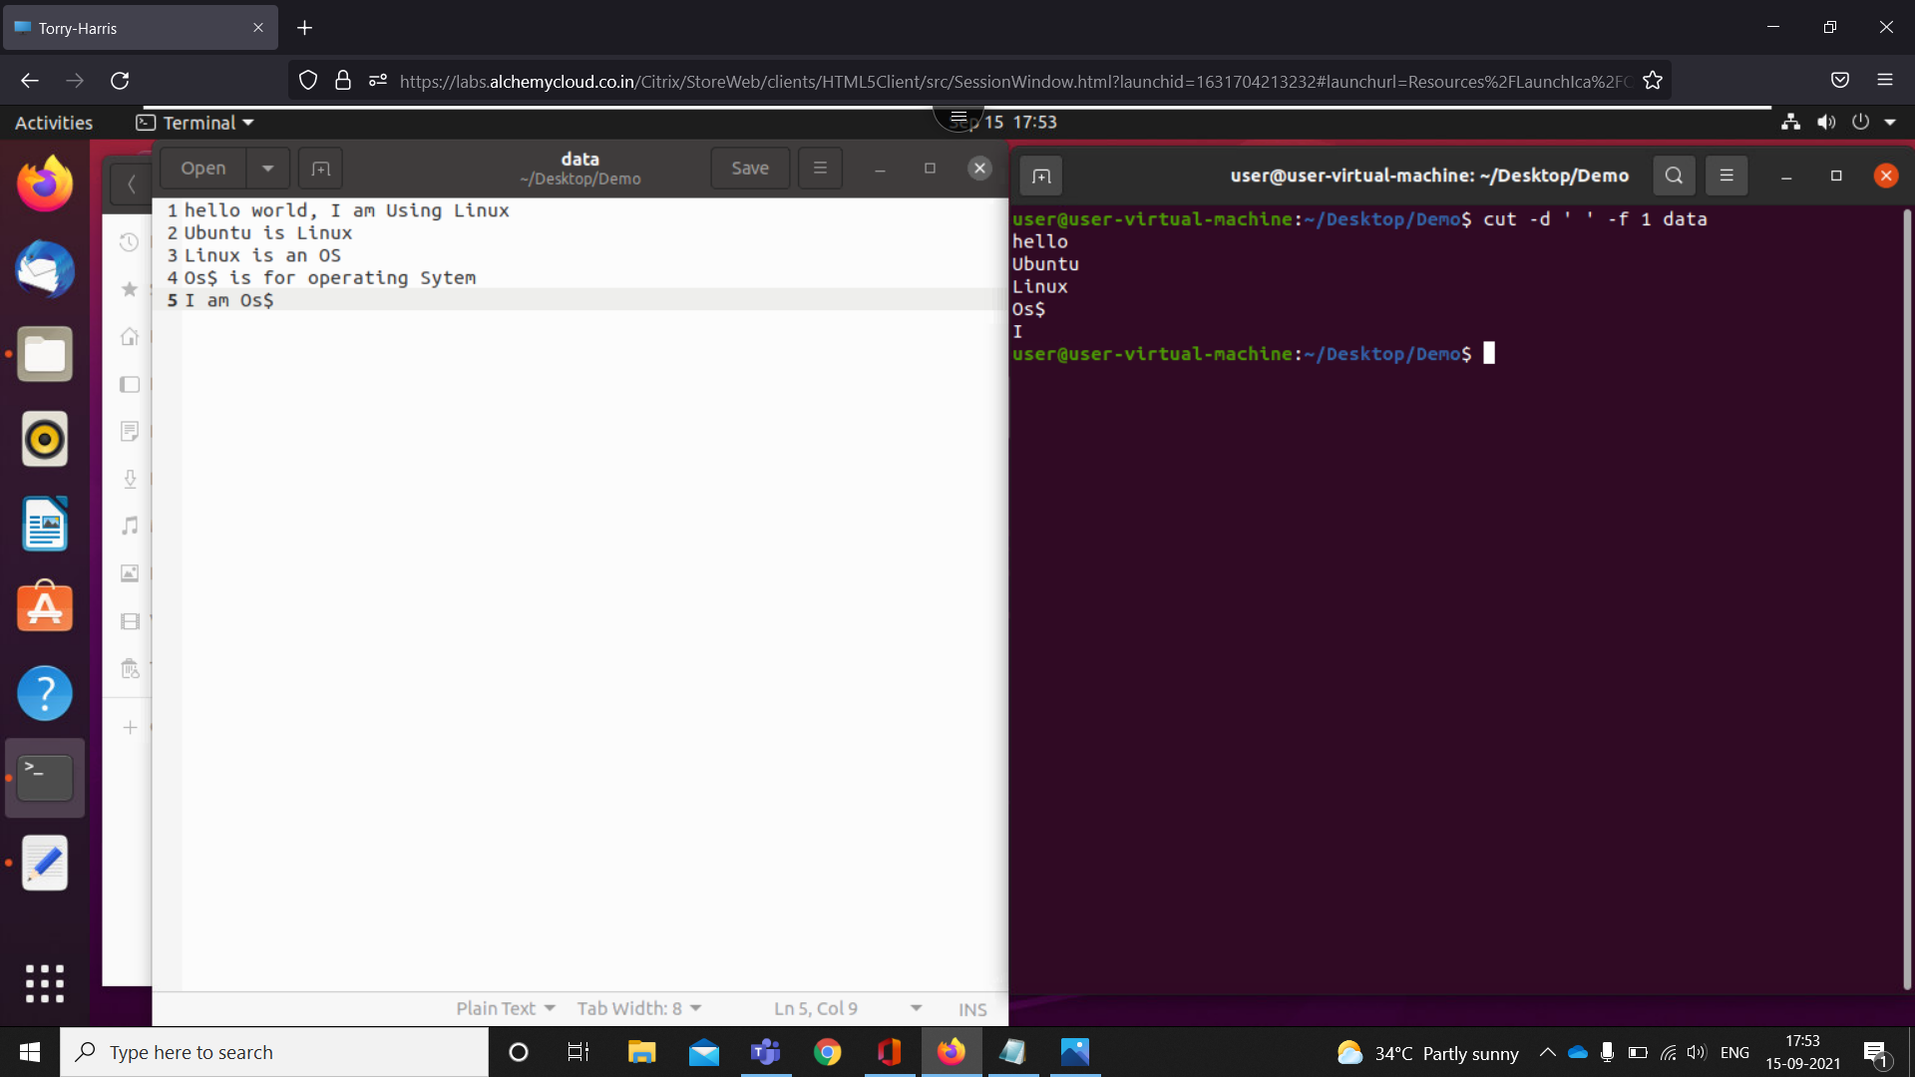

1. cut --complement -d ' ' -f 1 doc -print words after 1st space

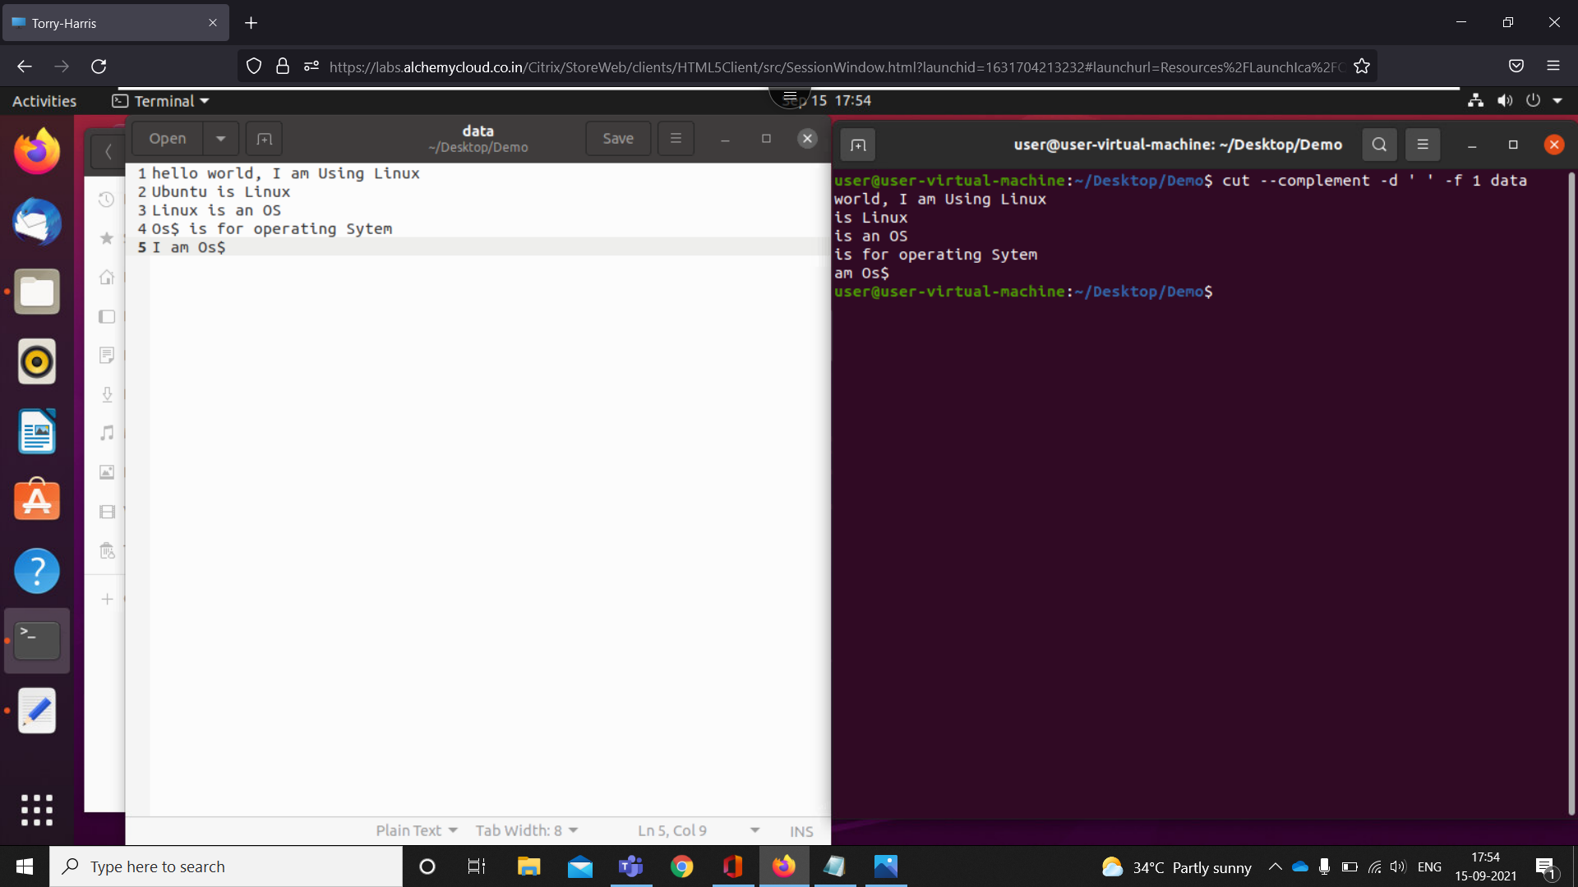

1. cut -d ' ' -f 3- data -print words after 3 spaces

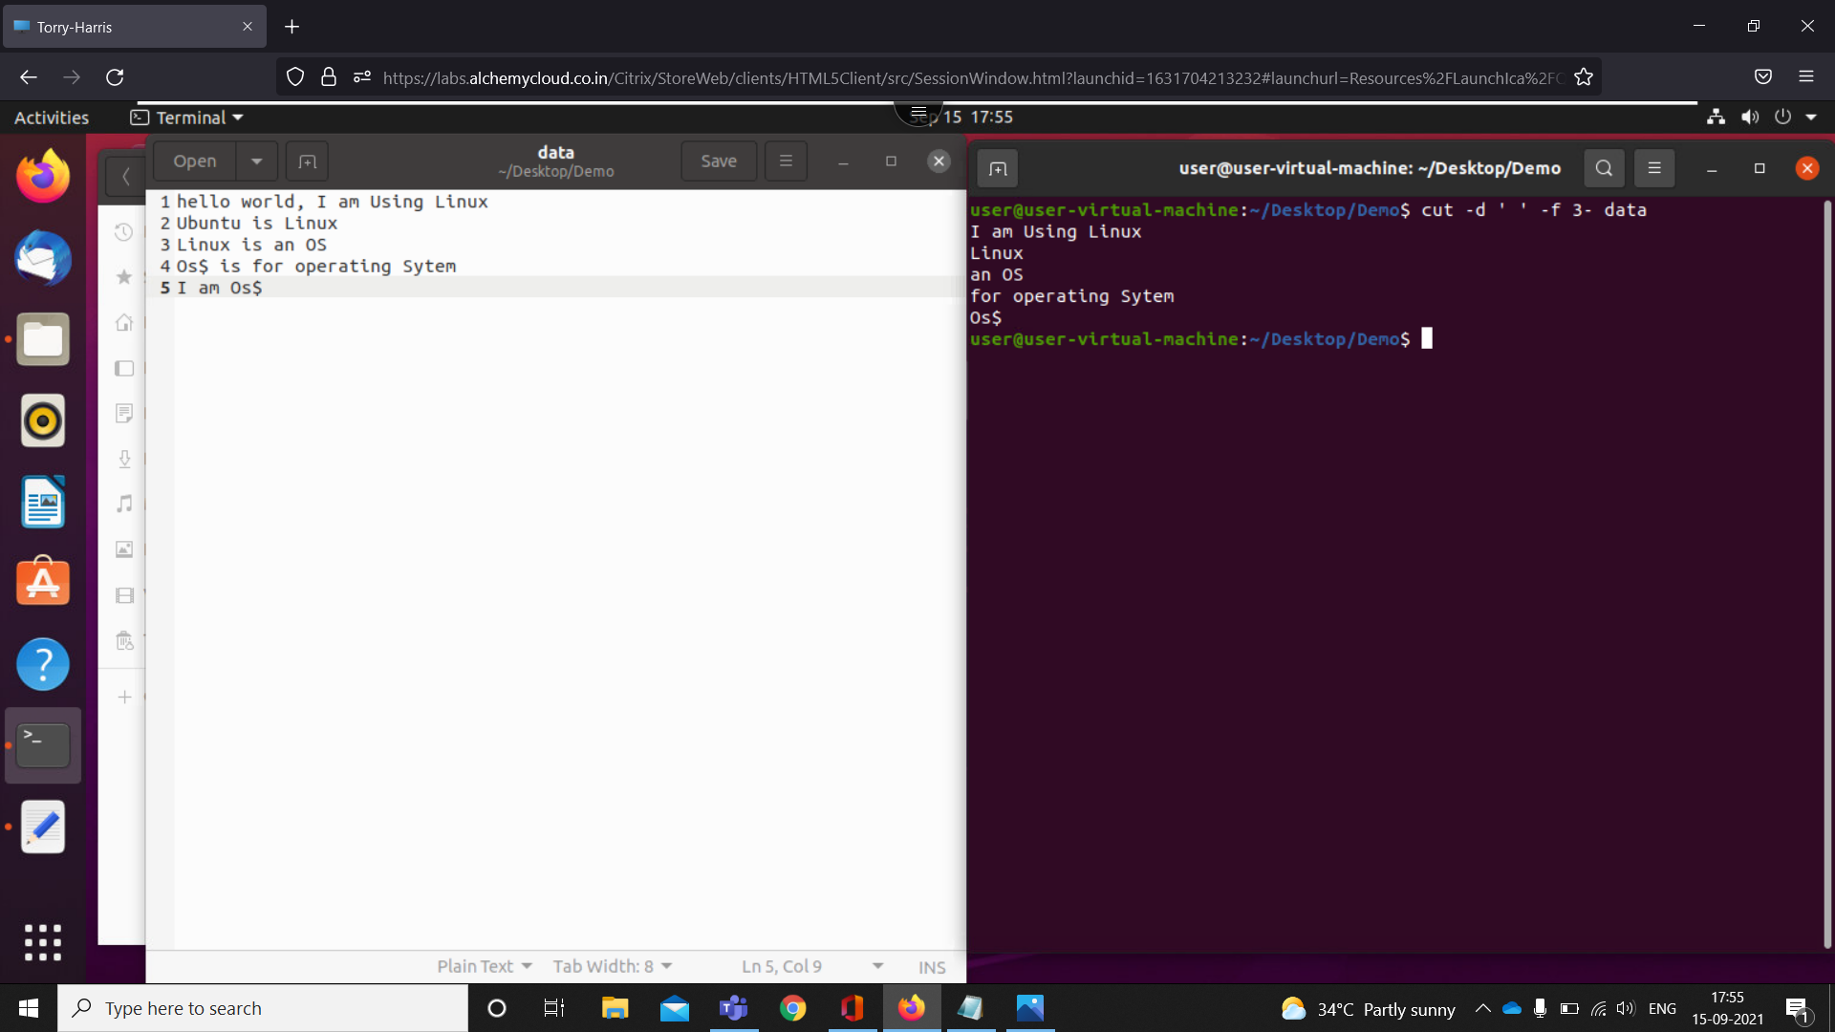

1. cut --complement -d ' ' -f 3- data - print words before 3

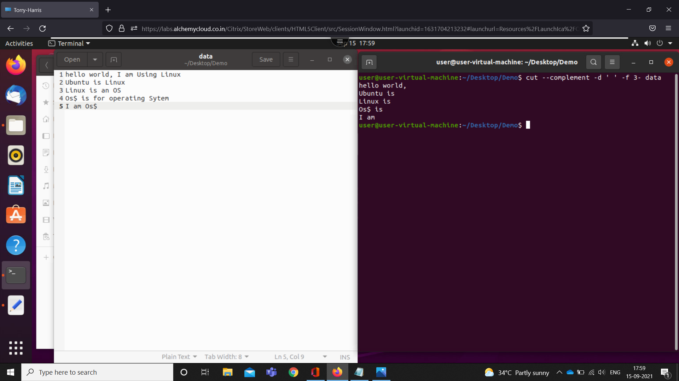

1. cut -c 1,5 data -prints 1 and 5 words in each line

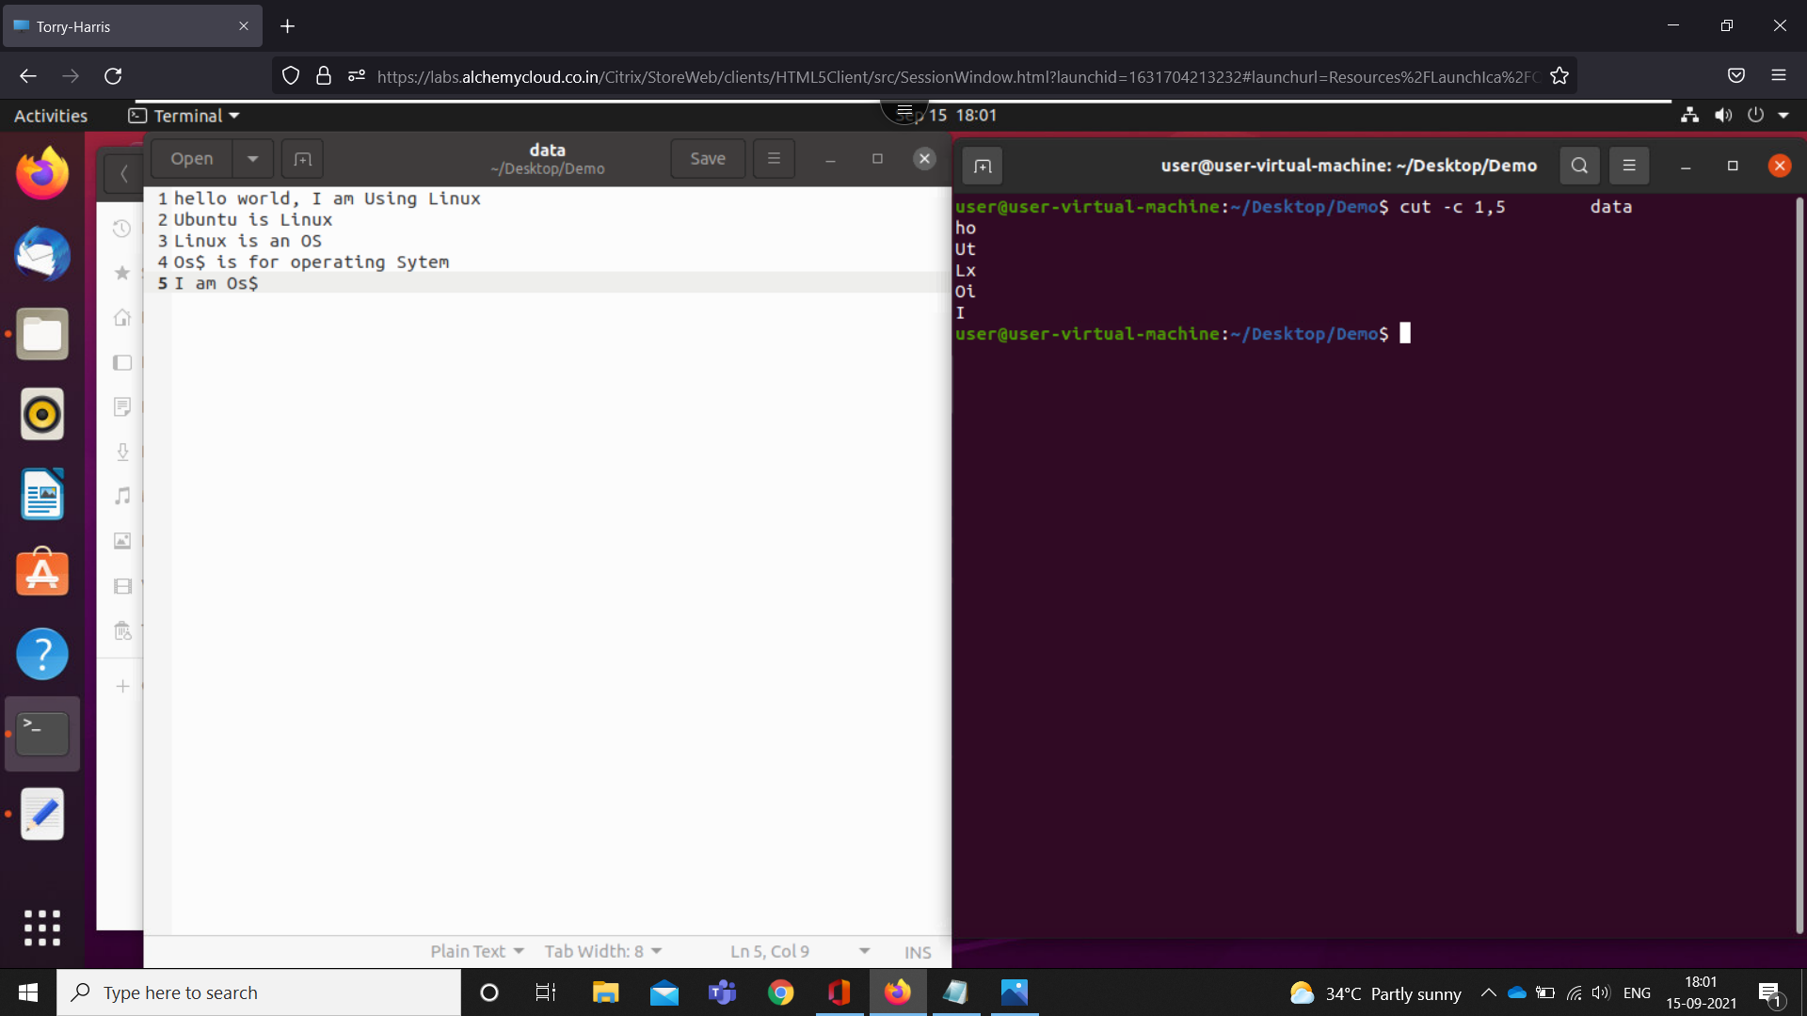

1. cut --complement -c 1,5 -prints words except 1 and 5

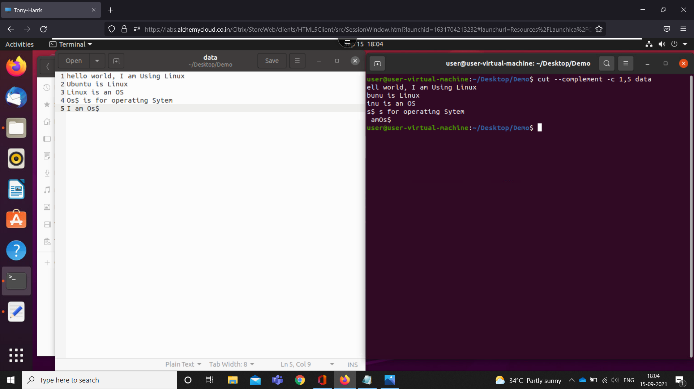

1. cut -d ' ' -f 1-2 data --output-delimiter='\*' -replace space with \* in between 1st and 2nd space

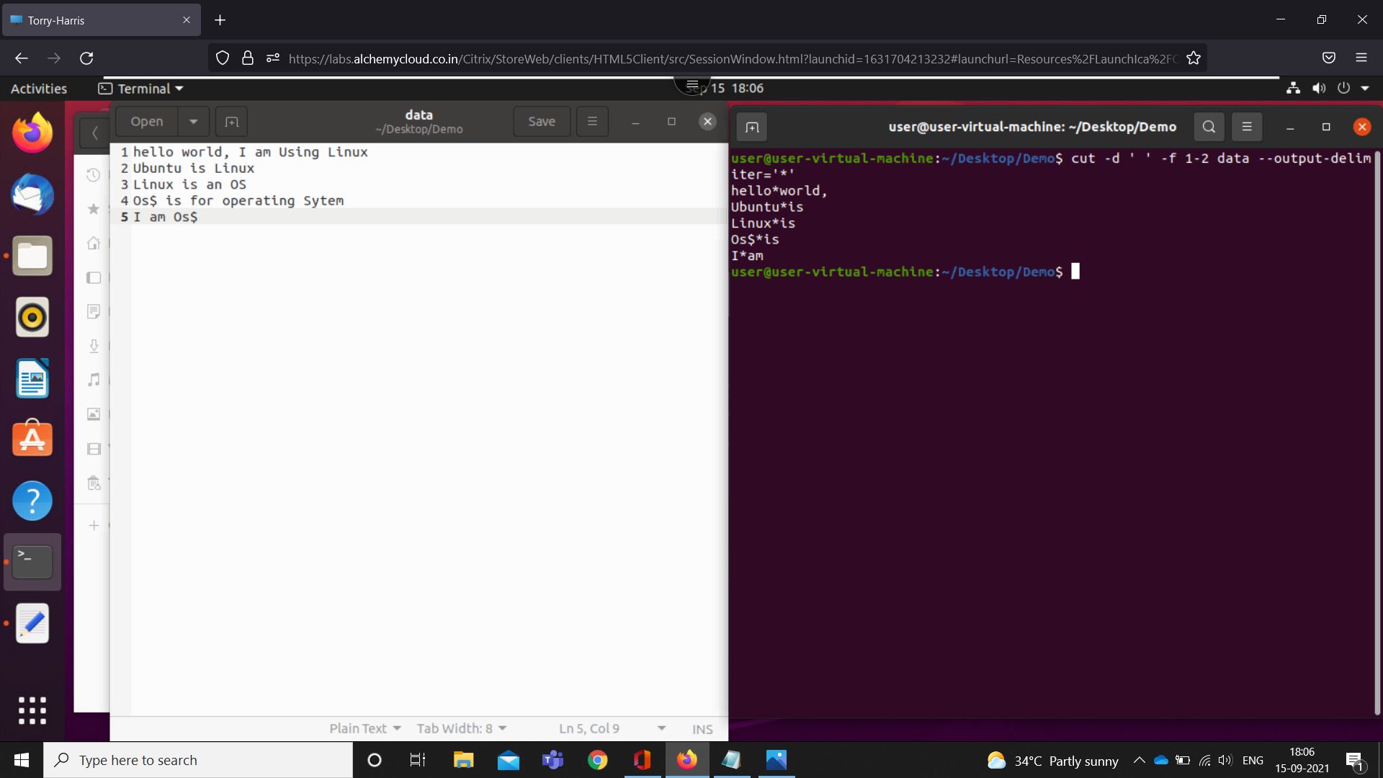

1. cut --complement -d ' ' -f 1-2 data --output-delimiter='\*' -replace space with \* after 2nd space

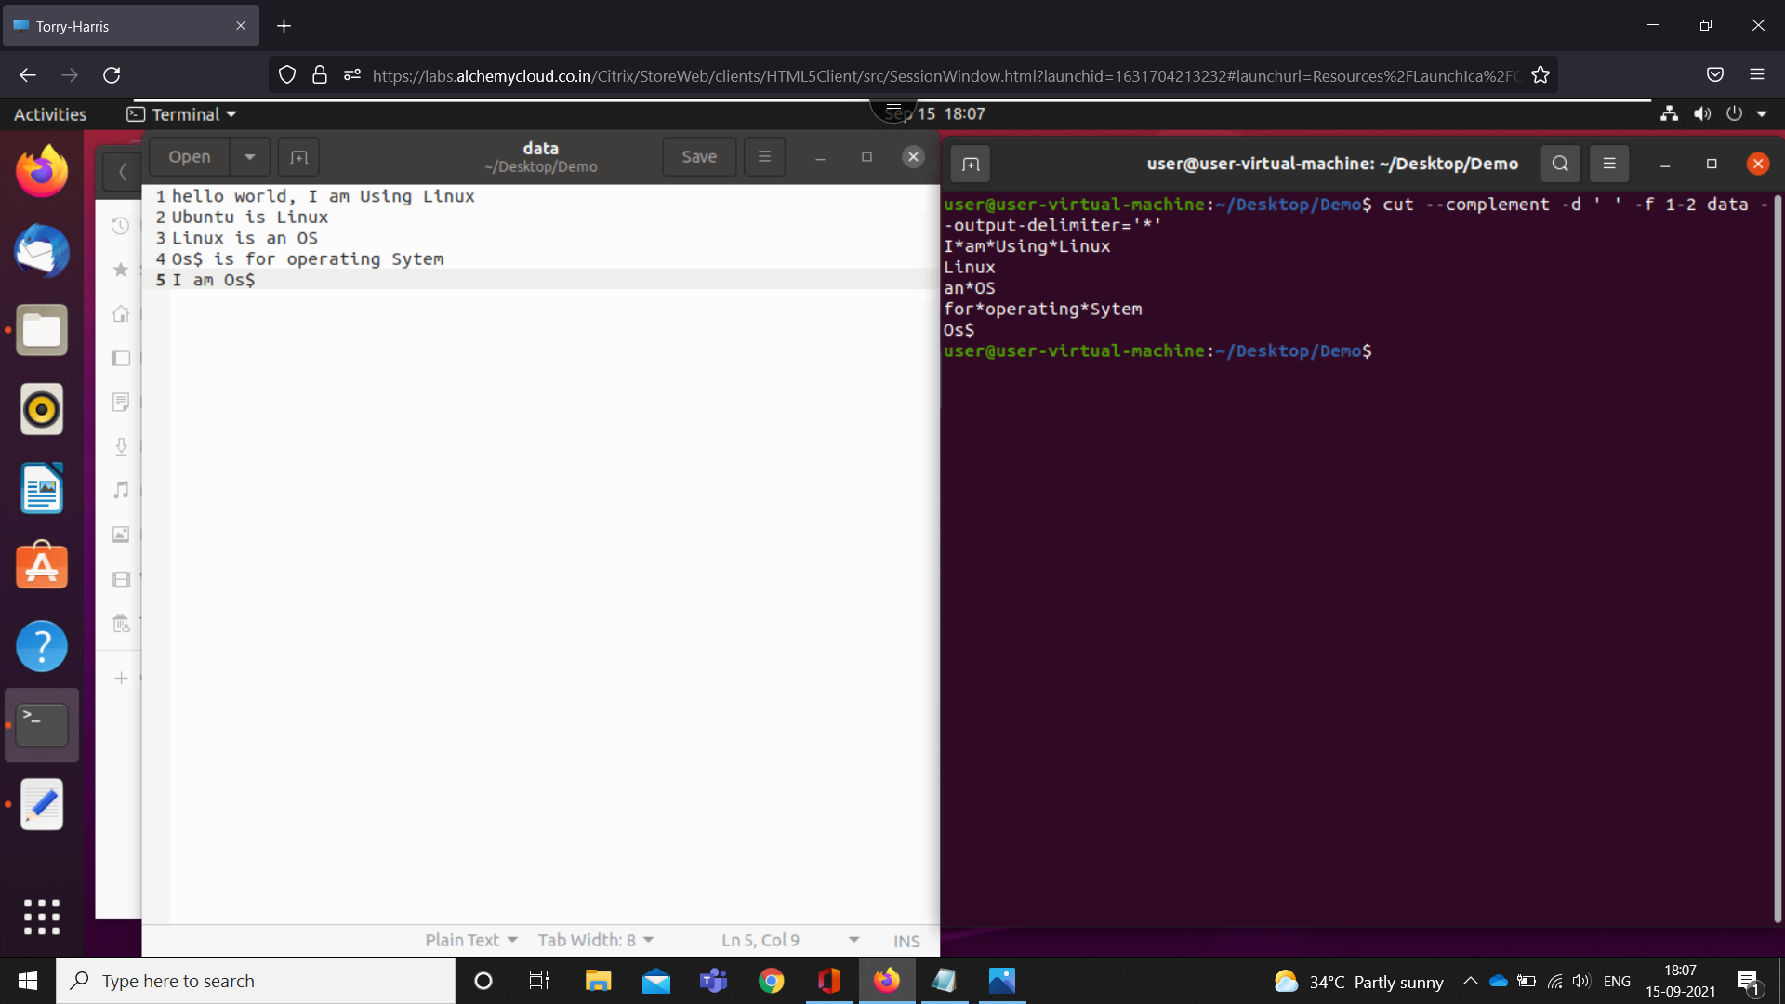

1. Cut –d ‘ ’ -f 1 data | sort - print sorted 1st word

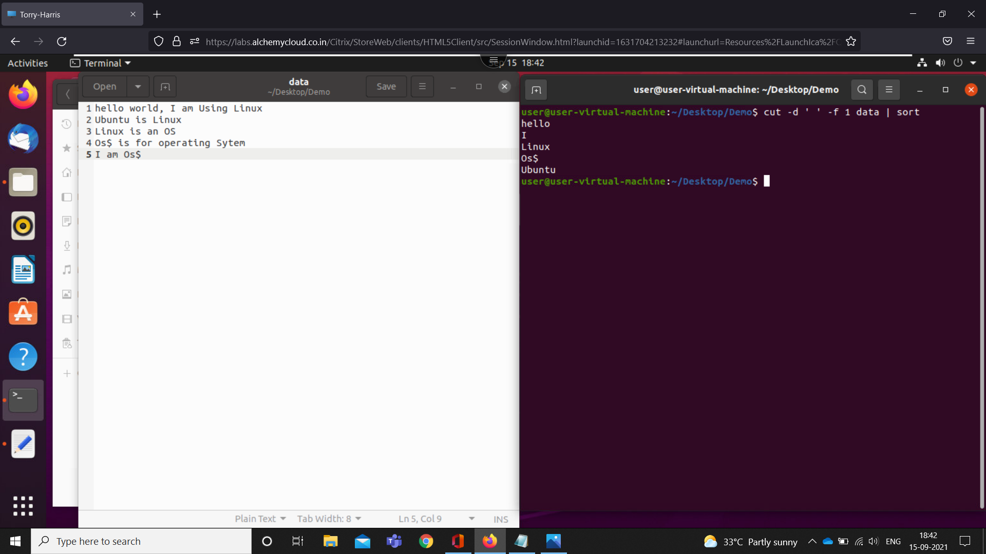

1. Cat data | cut –d ‘ ‘ -f 1-3| sort -print sorted 1st 3 words

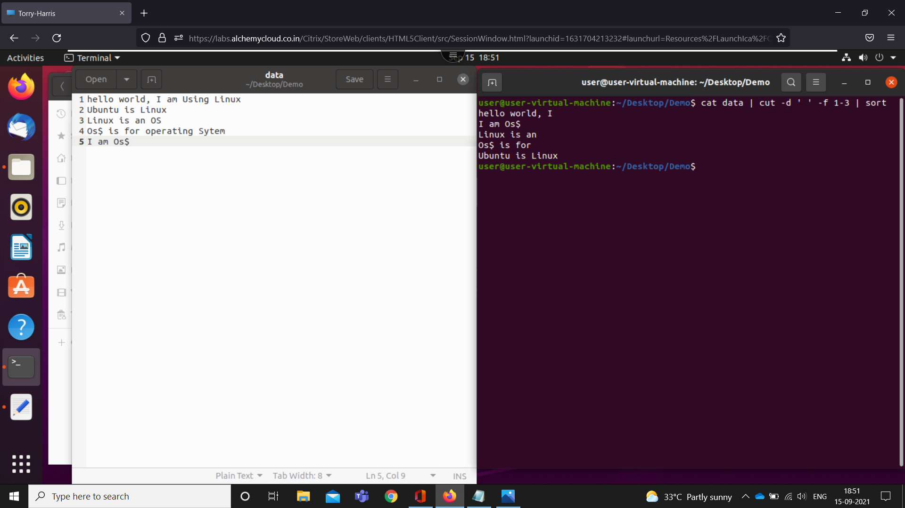

1. cat data | tr '[a-z]' '[A-Z]' -covert lowercase to upper
2. cat data | tr '[:lower:]' '[:upper:]' -convert low to up
3. echo 'hello world' | tr '[:space:]' '\t' -space to tab space
4. cat data | tr '[:space:]' '\t' -space to tab space
5. echo 'hello world' | tr '[:space:]' '\n' -space to newline
6. cat data | tr '[:space:]' '\n' -space to newline
7. cat data | tr [HI] [hi] -H to h and I to i
8. cat data | tr -d 'I' -delete that character
9. cat data | tr -d '[:digit:]' -delete all the digits
10. more doc - for partial display data

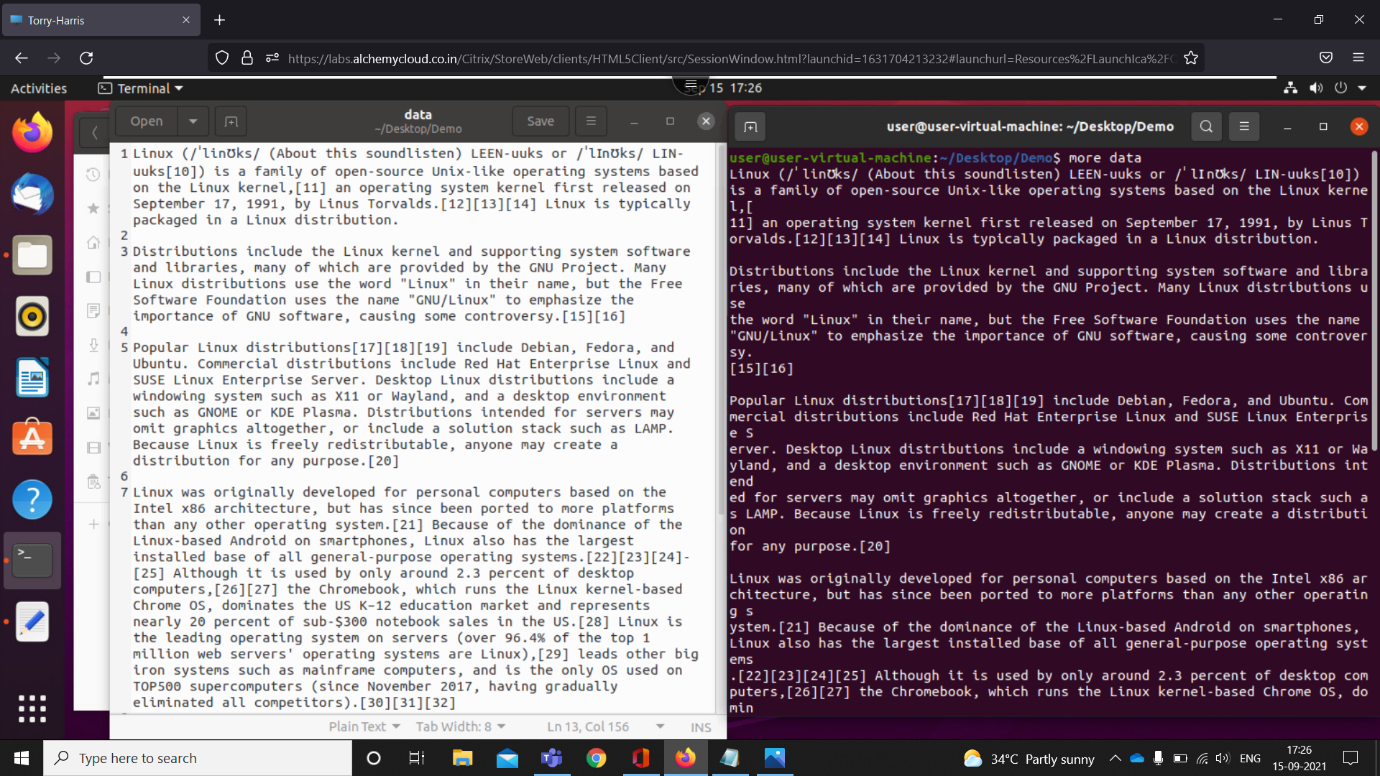

1. more -d doc -for instruction

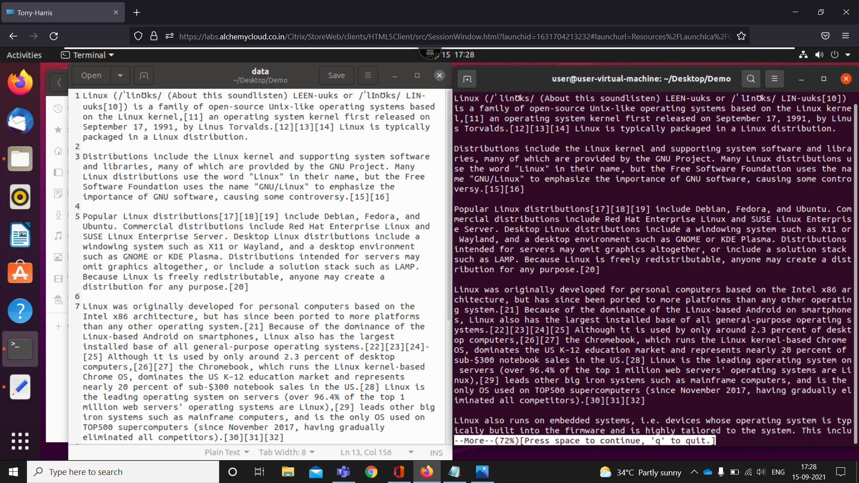

1. more -p doc - with more printed

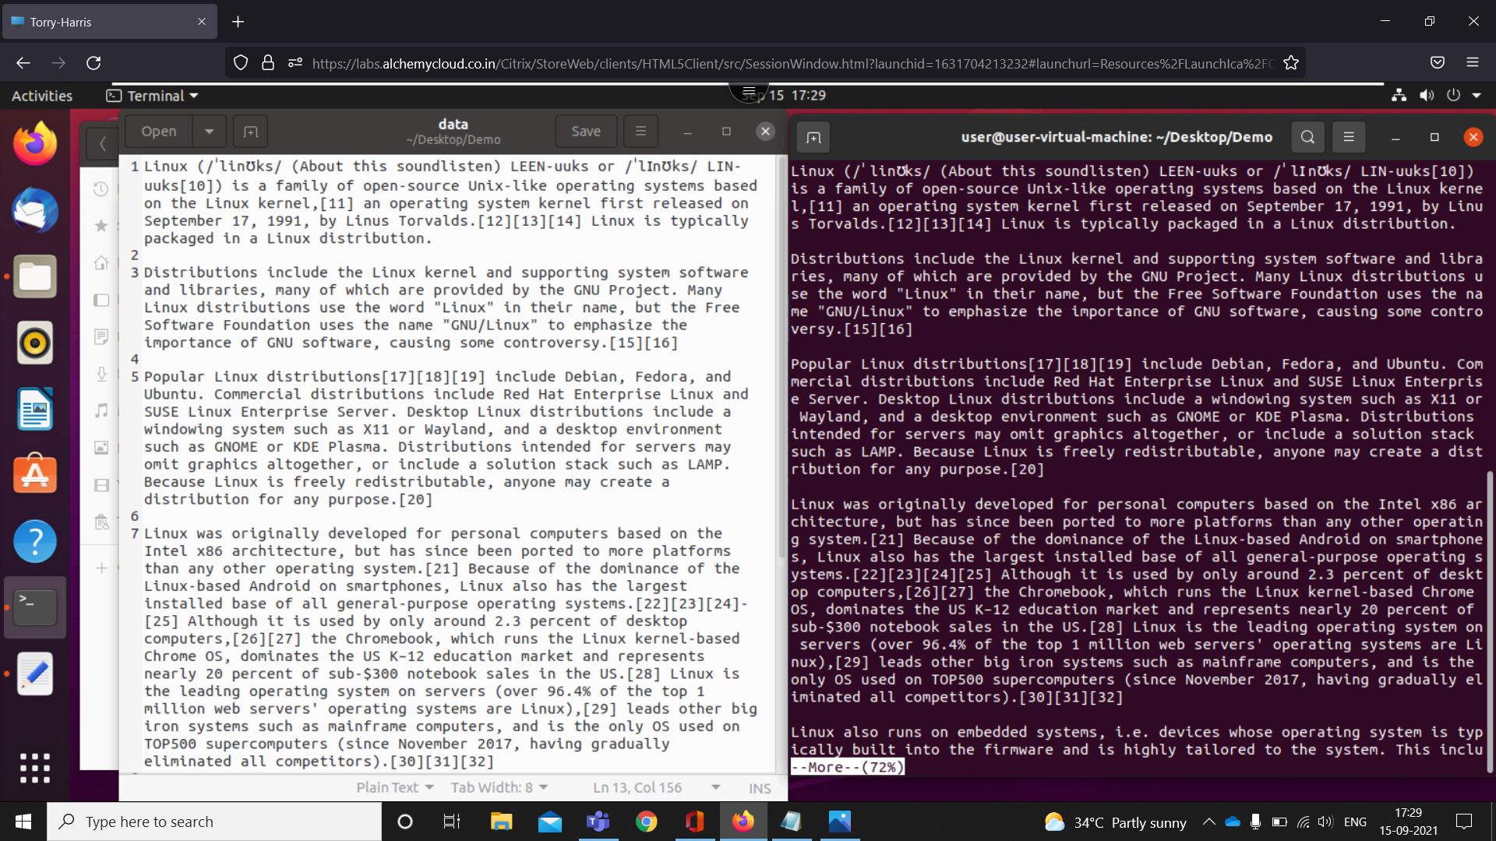

1. more -s doc -squeeze command

